Clothes Shopping Web Application  
Team 4 – User Guide

# Table Of Content

I. Website Address 3

II. Common Functions 3

1. Login with Email and Password 3

2. Login with Google 3

3. Forgot your Password 4

4. Normal Sign up 5

5. Sign up with Google 5

6. Logout 7

7. Update Profile 8

III. Guest 9

1. Shopping page (default page): 9

2. Filter Clothes by Category: 9

3. Search Clothes by Name 10

4. Add Clothes to Cart: 11

5. View Cart: 11

6. Remove Clothes from Cart: 12

IV. Registered Normal User 12

1. View order history: 13

2. View order history details: 14

3. Check out: 15

V. Admin 16

1. Create product 17

2. Edit product 18

3. View product detail 20

4. Filter product 21

5. Search product 22

6. Create category 22

7. View account list 23

8. Filter account by status 24

9. View account detail 26

10. View order list 27

11. View order detail 27

# Website Address

Access the web at <https://clothesshoppingwebapp20210713203725.azurewebsites.net/>

# Common Functions

These are the functions for all the web user, including unregistered and registered user, normal user, and admin.

## Login with Email and Password

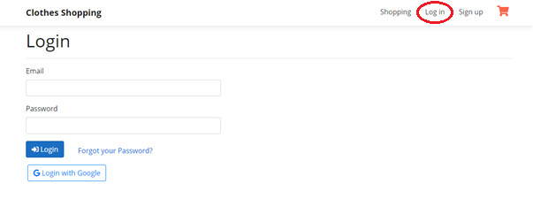

1. Click on the **‘Log in’** item on the top navigation bar.
2. Enter your Email and Password into the 2 inputs.
3. Click **‘Login’** button.

## Login with Google

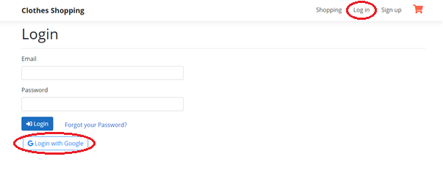

1. Click on the **‘Log in’** item on the top navigation bar.
2. Click **‘Login with Google’** button.

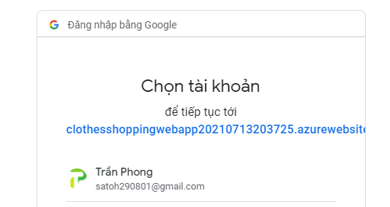

1. Login into your Google account. Make sure you have registered your email with our system, otherwise the browser will display the *Sign up*screen.

## Forgot your Password

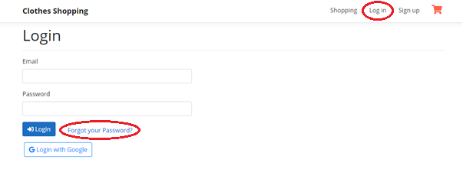

1. Click on the **‘Log in’** item on the top navigation bar.
2. Click on the **‘Forgot your Password?’** link.

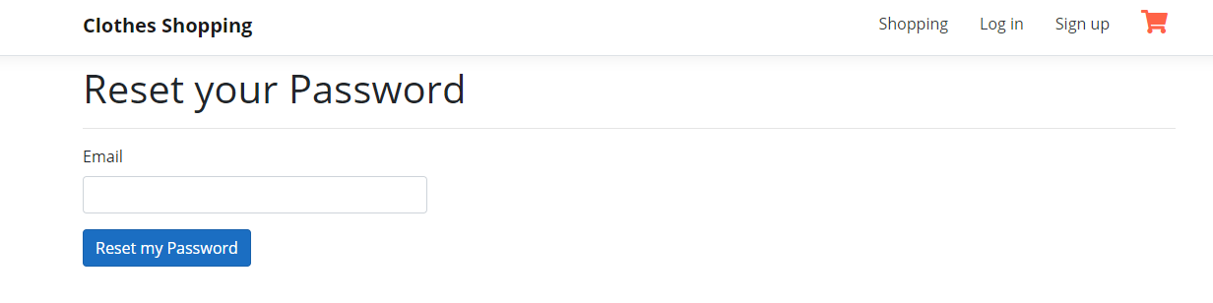

1. Enter your Email. Ensure that you have an account in our system with that Email.
2. Click **‘Reset my Password’** button.
3. After the success message is shown, check your email for your new Password.

## Normal Sign up

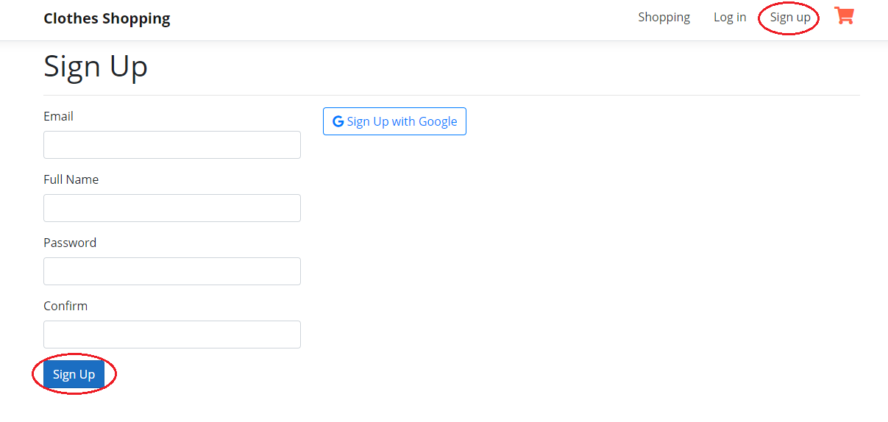

1. Click on the **‘Sign up’** item on the top navigation bar.
2. Fill up all the required fields with your information.
3. Click **‘Sign Up’** button to submit. After successfully signing up, you will be redirected to the **‘Log in’** screen.

## Sign up with Google

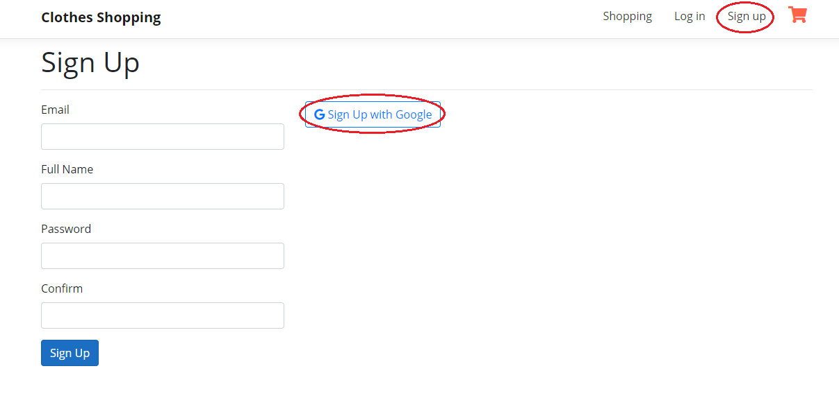

1. Click on the **‘Sign up’** item on the top navigation bar.
2. Click **‘Sign Up with Google’** button.

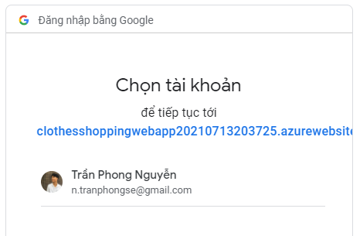

1. Login into your Google account. Make sure that you haven’t registered an account with the email in our system before, otherwise, you will be redirected to **‘Log in’** function and go to Home page. If you haven’t registered an account with the email in our system before, the **‘Sign up’** screen will display with your Google information.

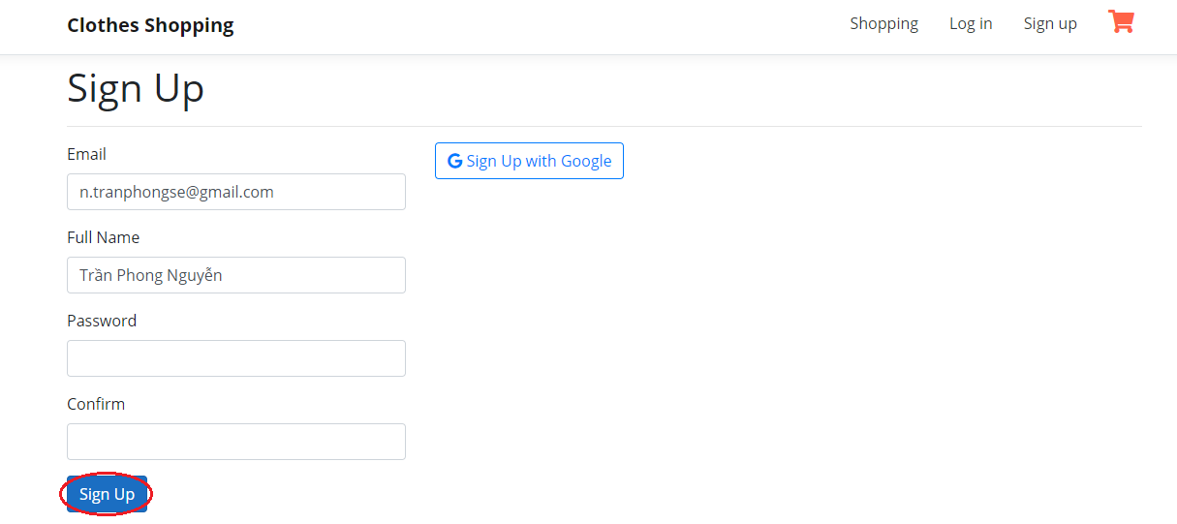

1. Enter your password and edit the name if needed.
2. Click **‘Sign Up’** button to submit. After successfully signing up, you will be redirected to the **‘Log in’** screen.

## Logout

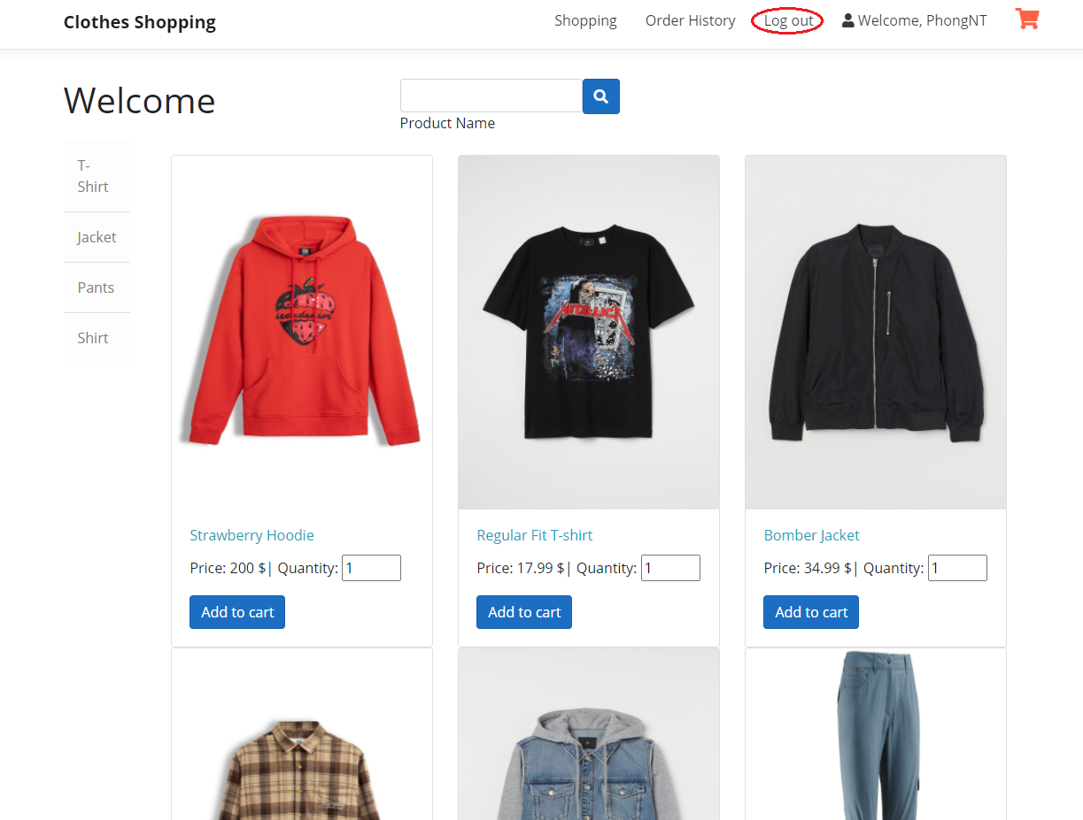

After you have logged into our system, if you want to log out, click on the **‘Log out’** item on the top navigation bar. Logging out successfully will redirect you to the **‘Log in’** screen.

## Update Profile

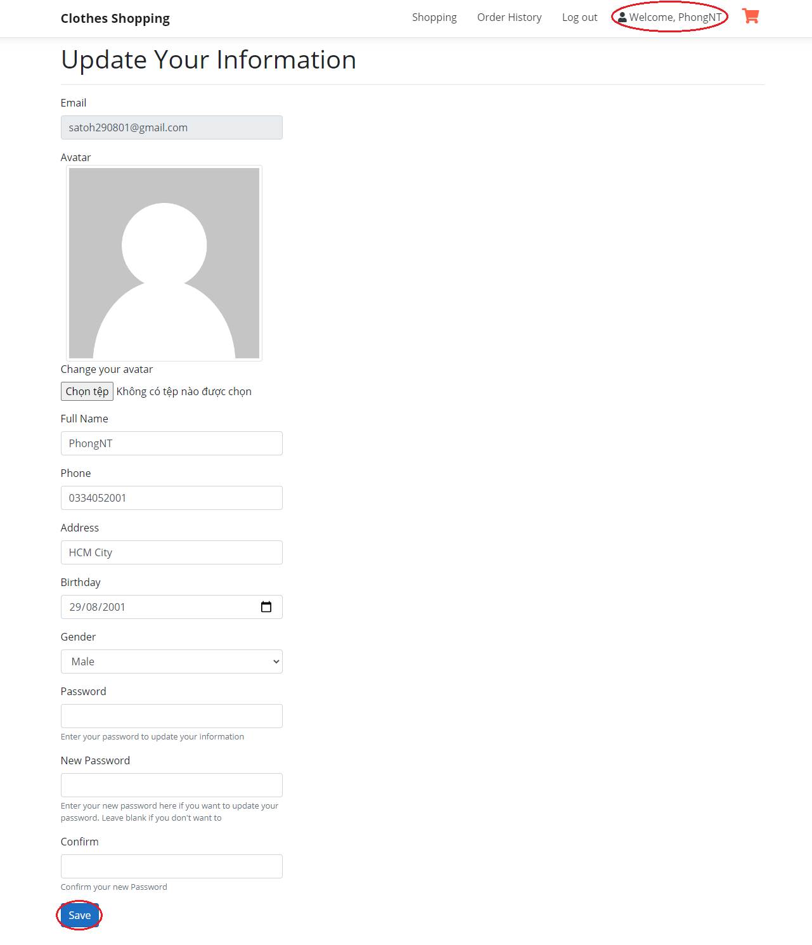

1. After you have logged into the system, click on the **‘Welcome…’** item on the top navigation bar to update your profile.
2. Fill out all the information you want to update, including your avatar and your password. Your email is not allowed to be updated. The **‘Password’** field must be your current password. If you want to update to a new one, please enter it in the **‘New Password’** and **‘Confirm’** fields.
3. Click **‘Save’** button after you have done all the information.

# Guest

These are functions for both unregistered user and registered normal user but not admin.

## Shopping page (default page):

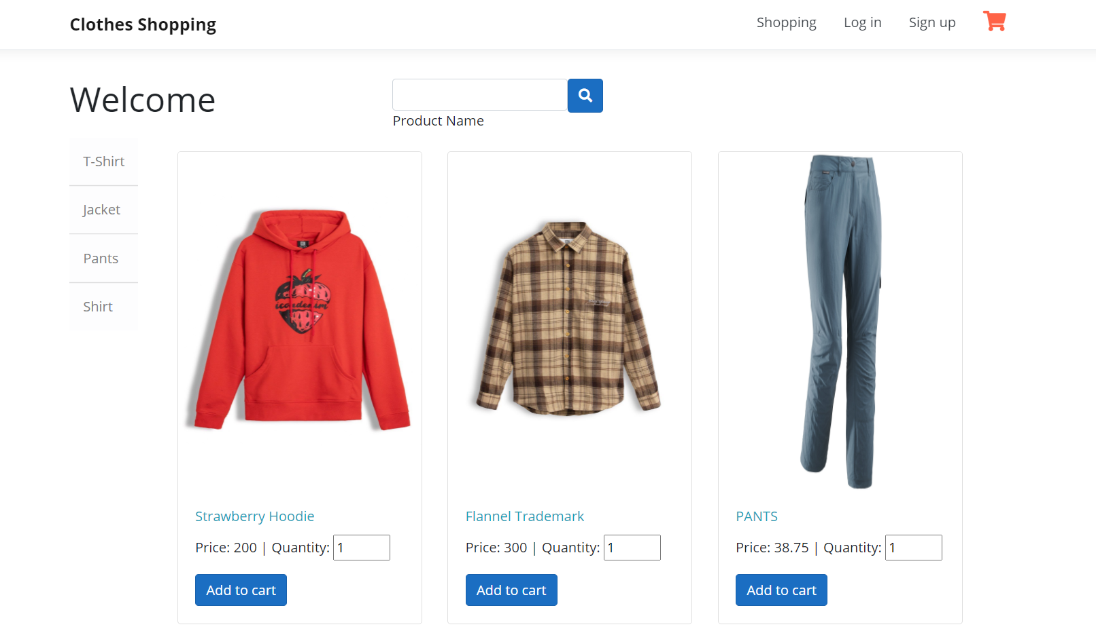

*This is the default Guest Page when a Guest visits our website.*

## Filter Clothes by Category:

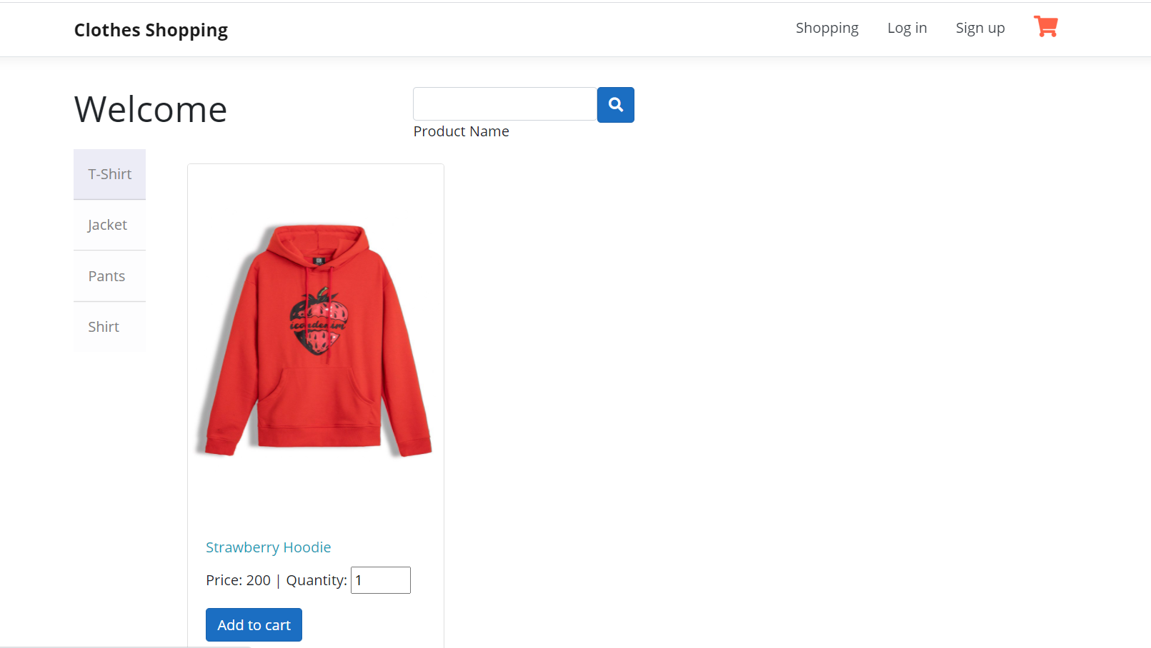

Click on each Category on the left side for Filtering Clothes by Category.

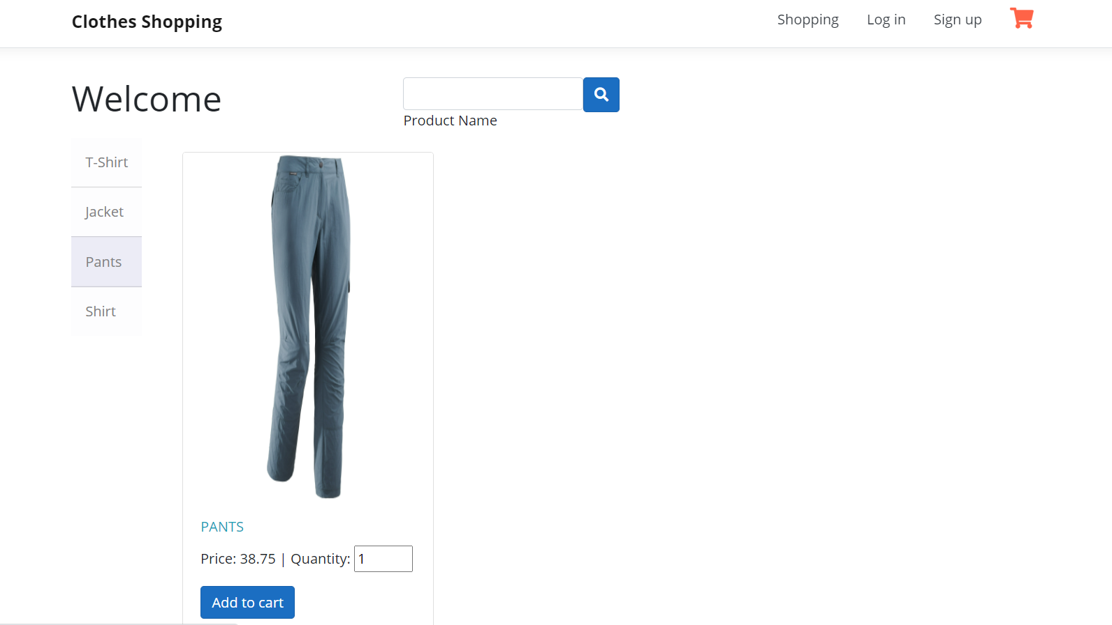

## Search Clothes by Name

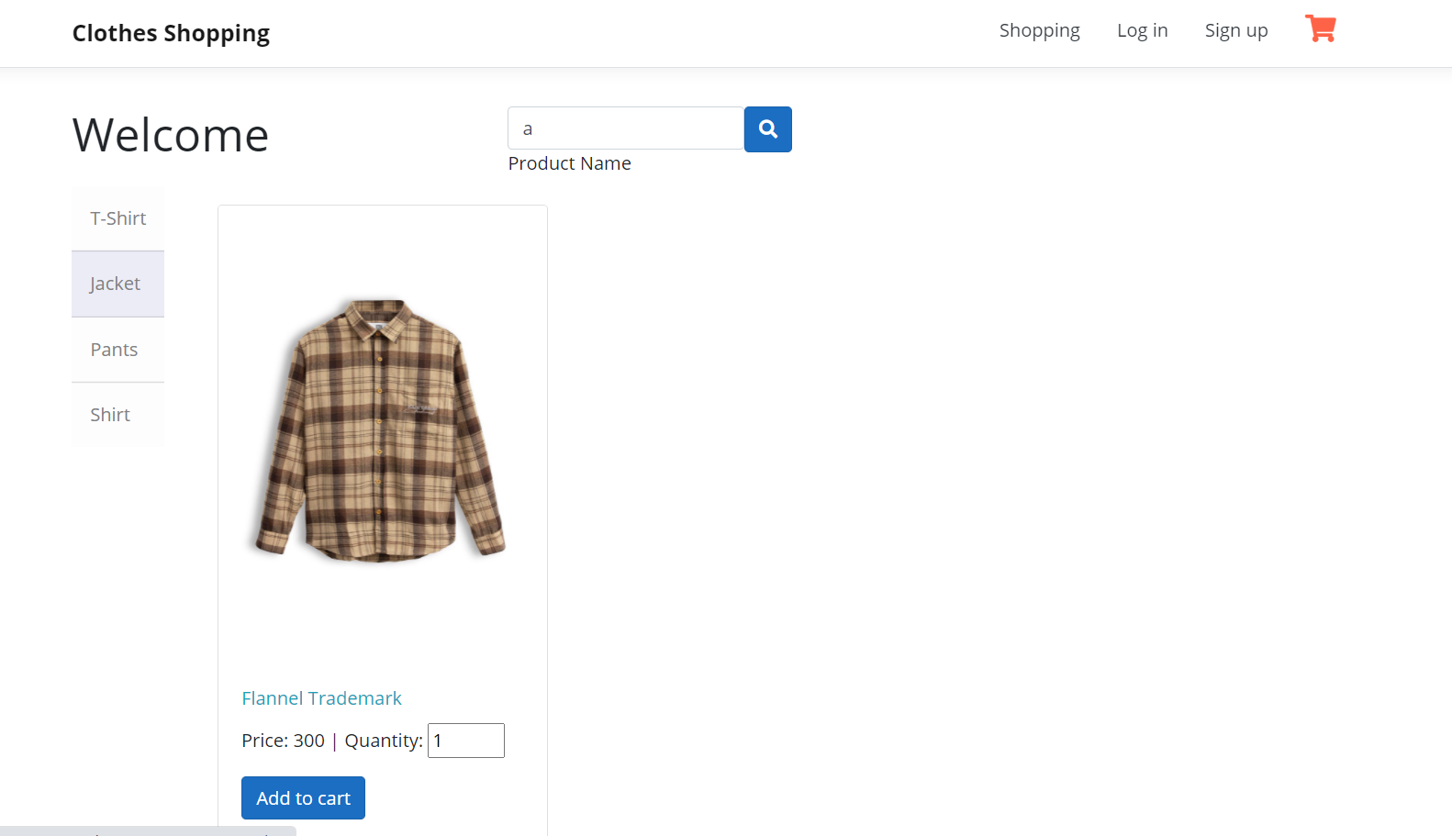

Enter the keyword of Cloth’s Name and Enter/Click on Search icon for Searching.

## Add Clothes to Cart:

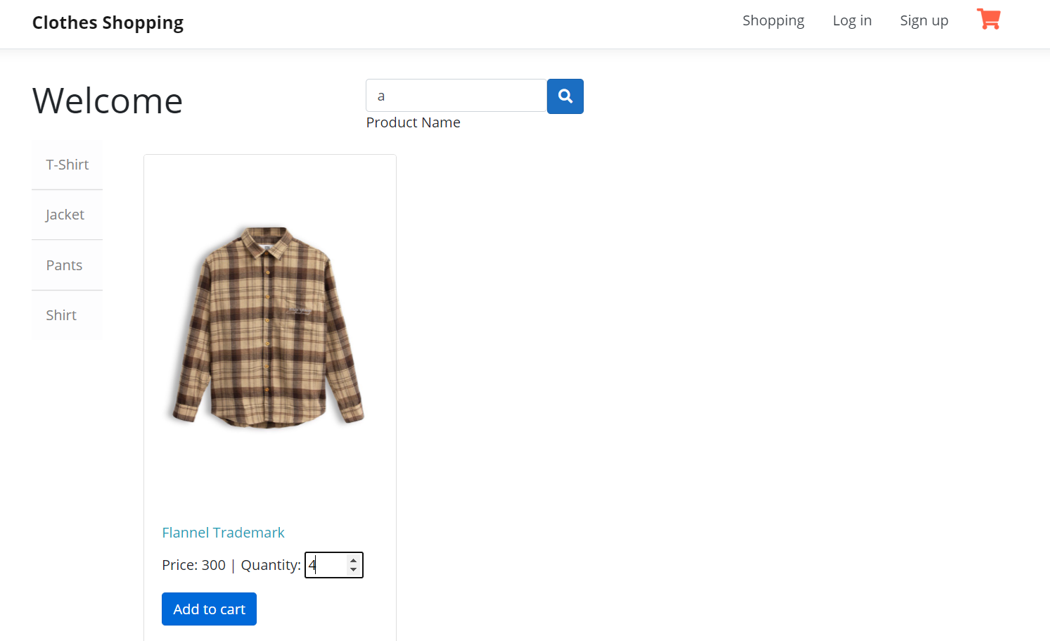

Increase/Decrease/Enter Quantity then Click **“Add to cart”** button to add Clothes to Cart.

## View Cart:

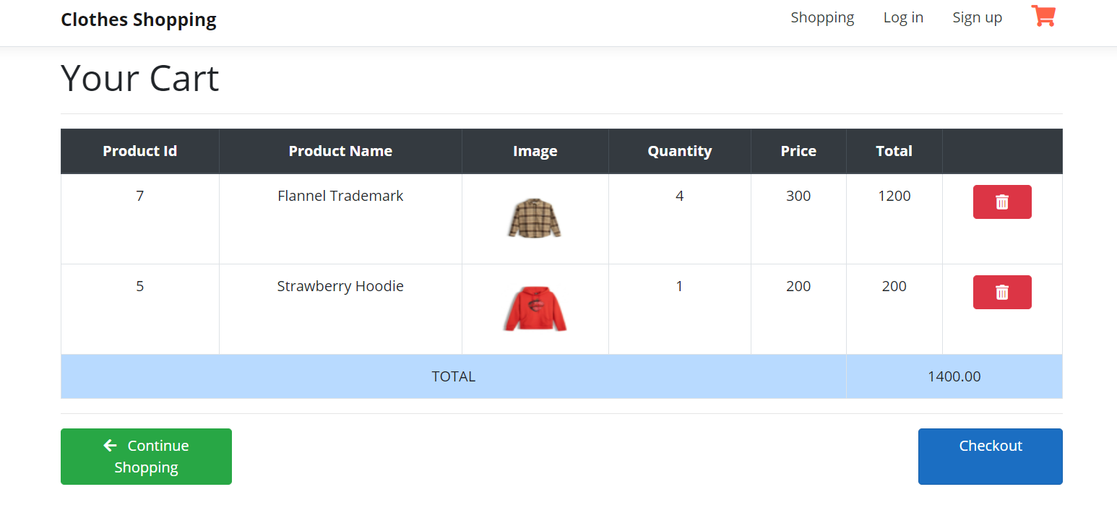

To view your cart, Click on the Cart icon at the top-right corner.

## Remove Clothes from Cart:

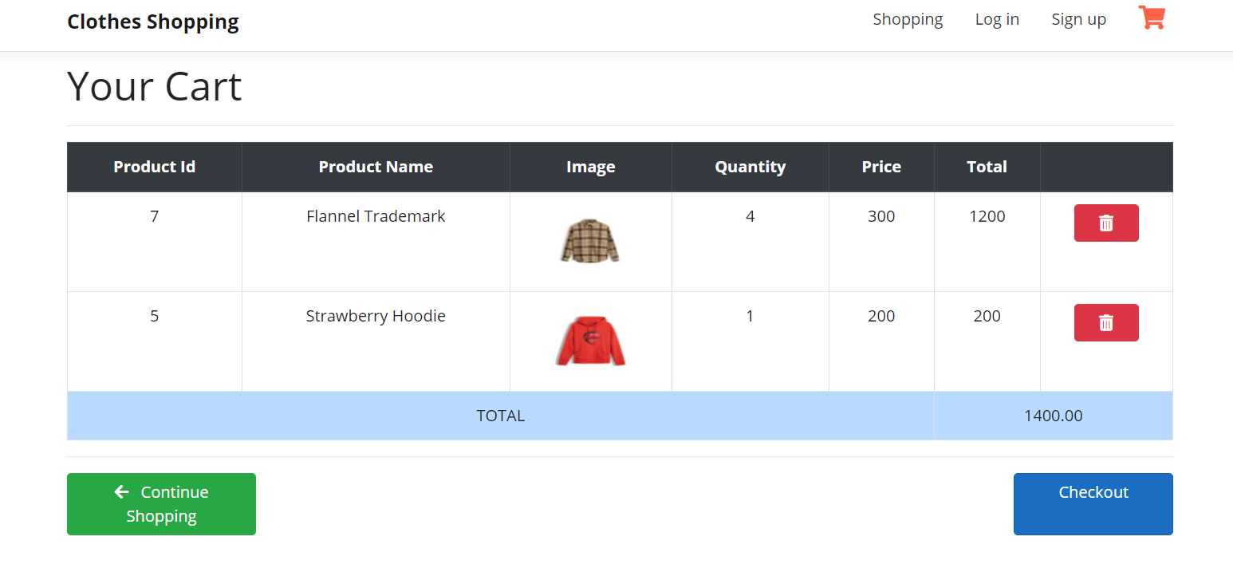

Click on the Trash icon of the Cloth you want to remove from the cart.

*EX: Click on the Trash icon of “Strawberry Hoodie” and the screen would be...*

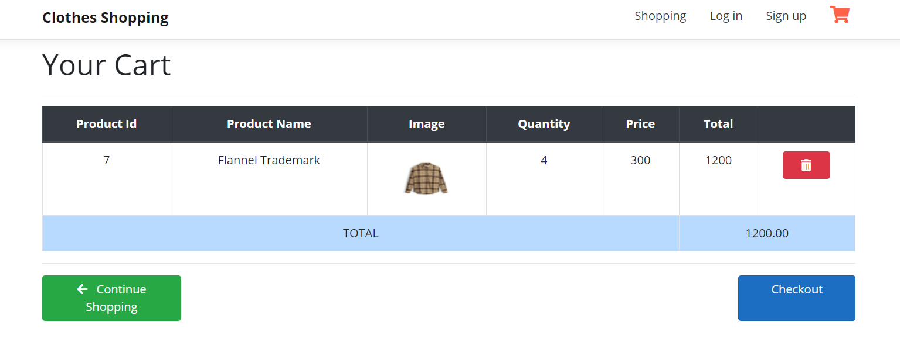

Click on **Continue Shopping** or **Shopping** (on the Menu) to return to the Shopping page.

# Registered Normal User

These are the functions for normal registered web user (not-admin user).

**Test account:**

**Email:** satoh290801@gmail.com

**Password:** 123456789

## View order history:

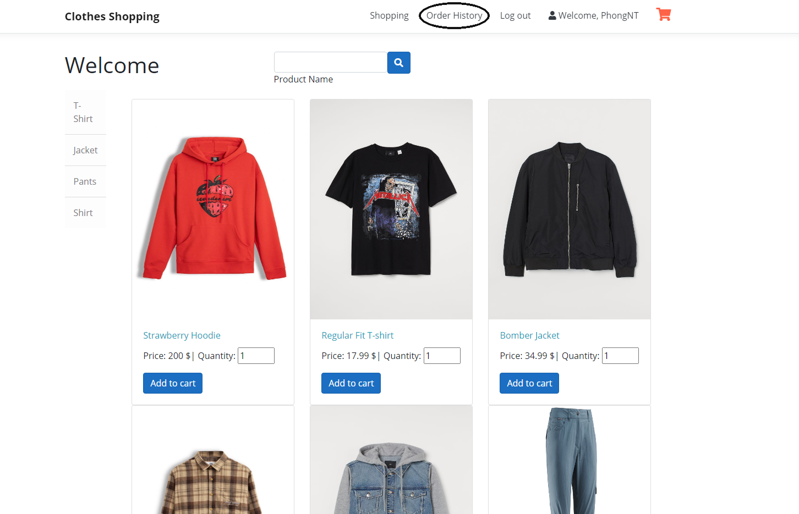

Click on **“Order History”** on the navigation bar to view your order history.

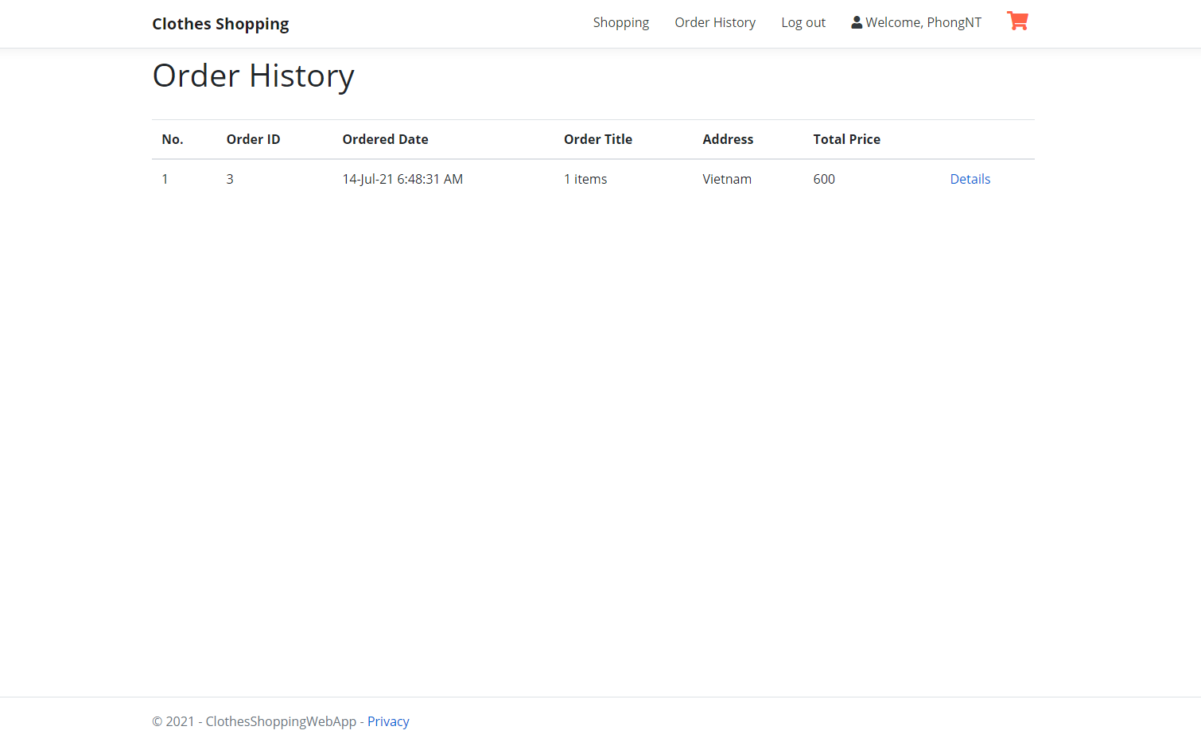

## View order history details:

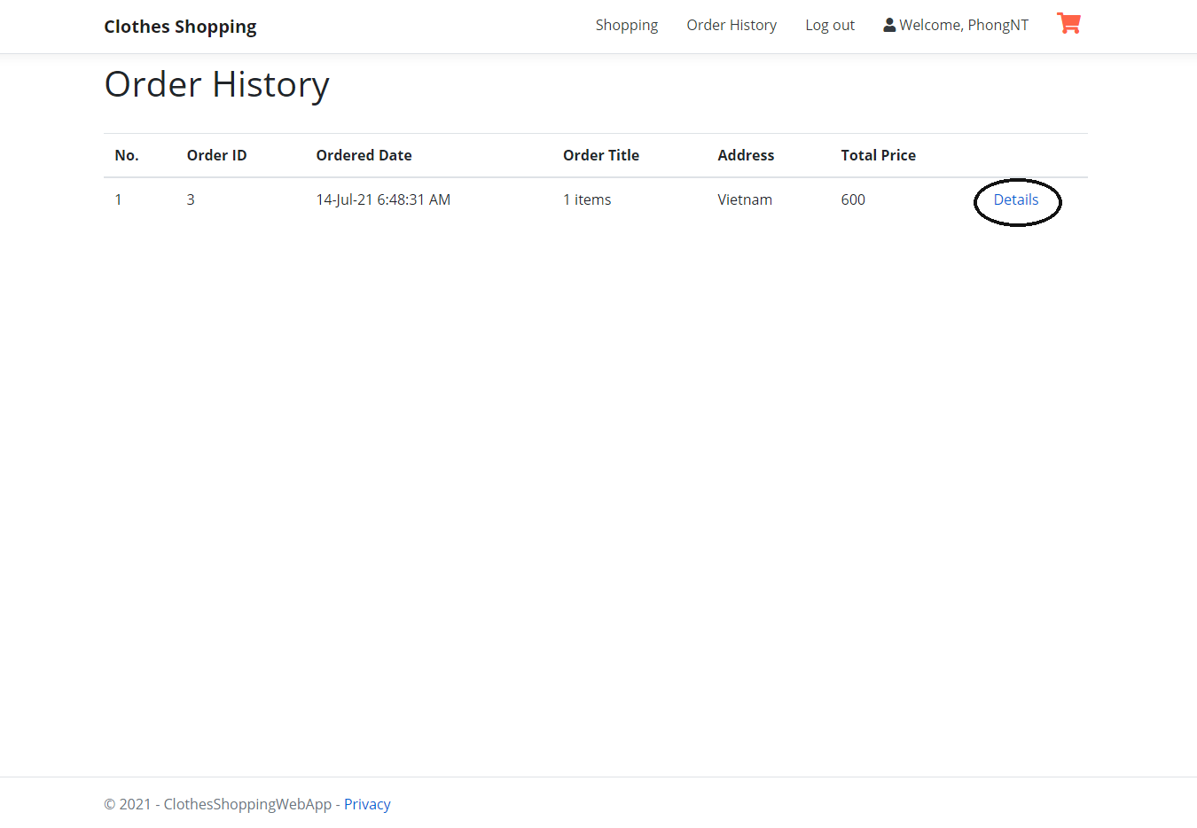

1. This is your order history page, which stores all the orders you have placed.
2. Click on “Details” to view details of an order.

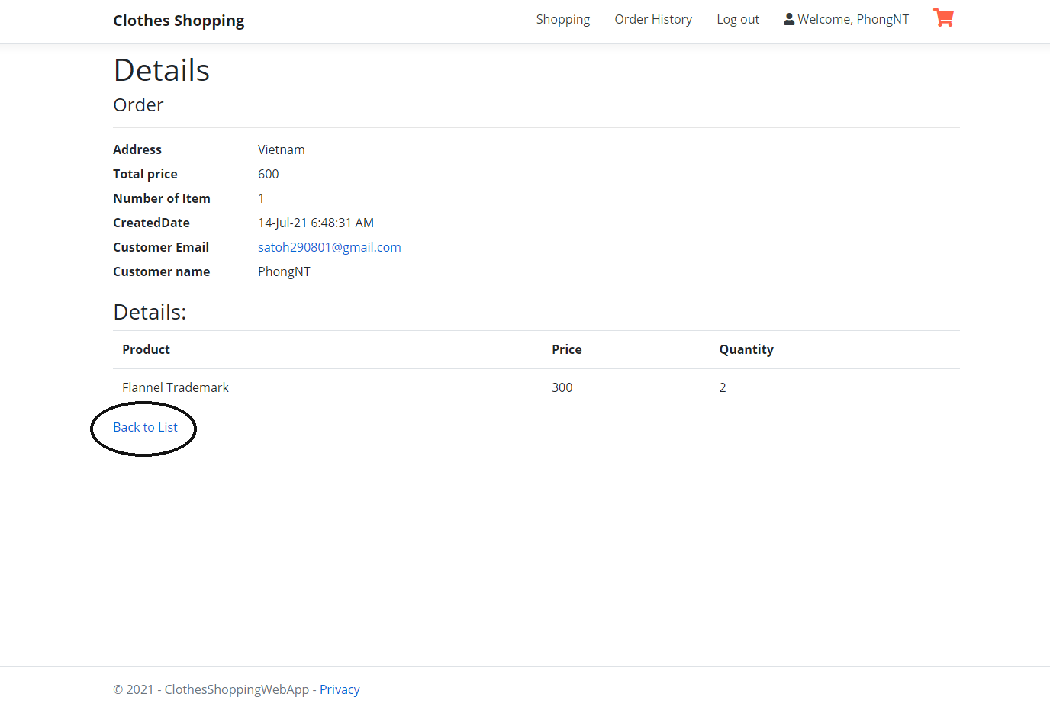

1. Click on **“Back to List”** to return to the list of your placed orders.

## Check out:

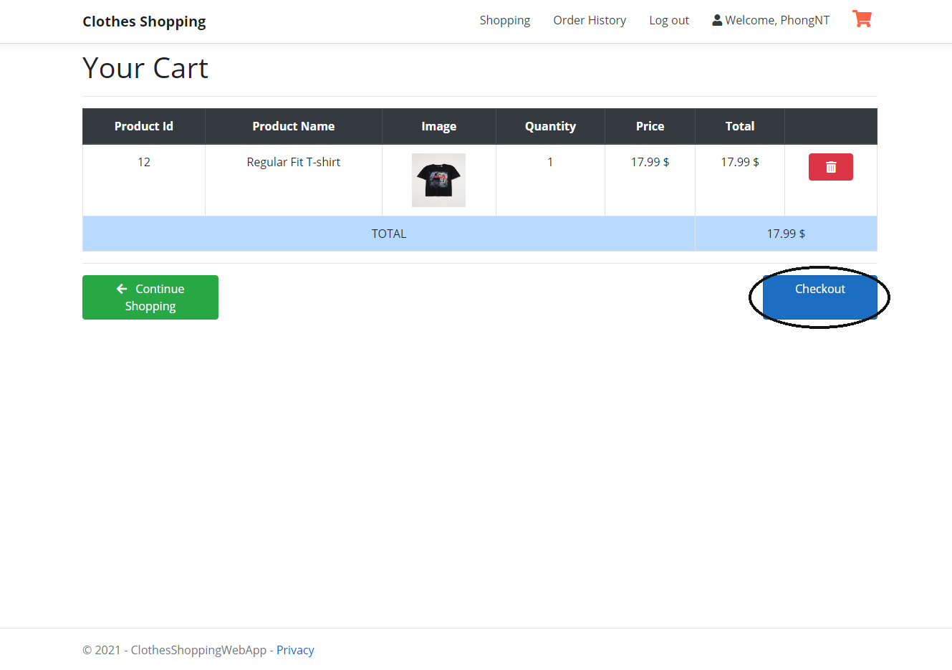

1. Go to your cart, click on “Checkout” to get to the confirmation screen.

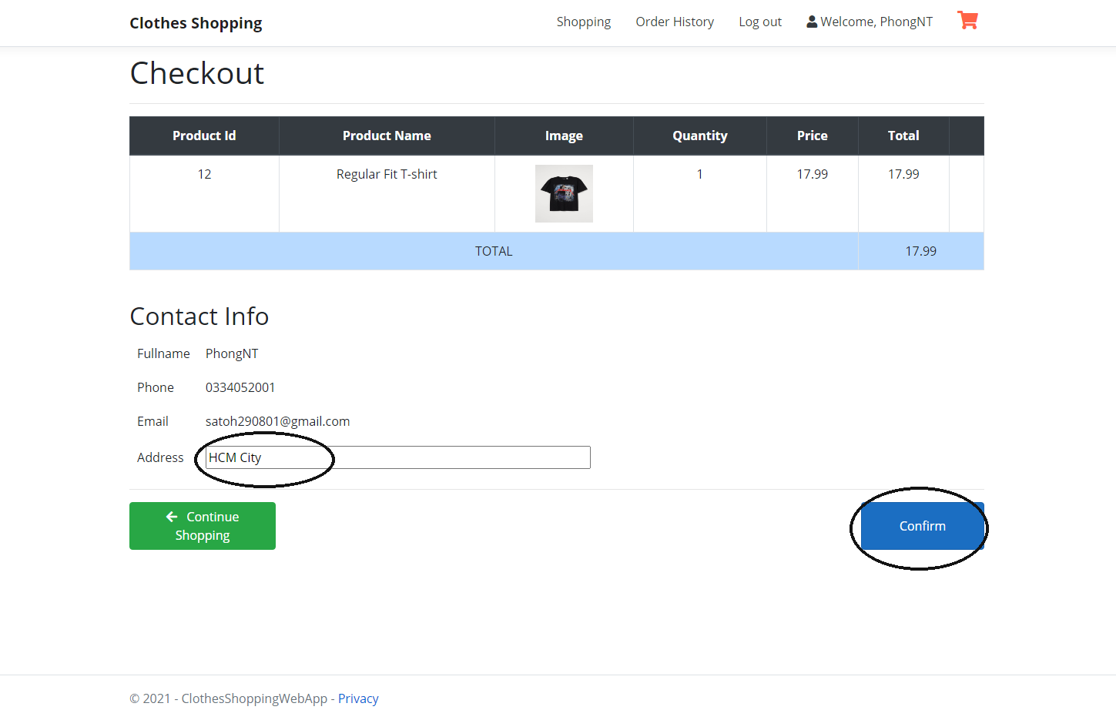

1. Edit the **“Address”** field if necessary and click on the **“Confirm”** button.

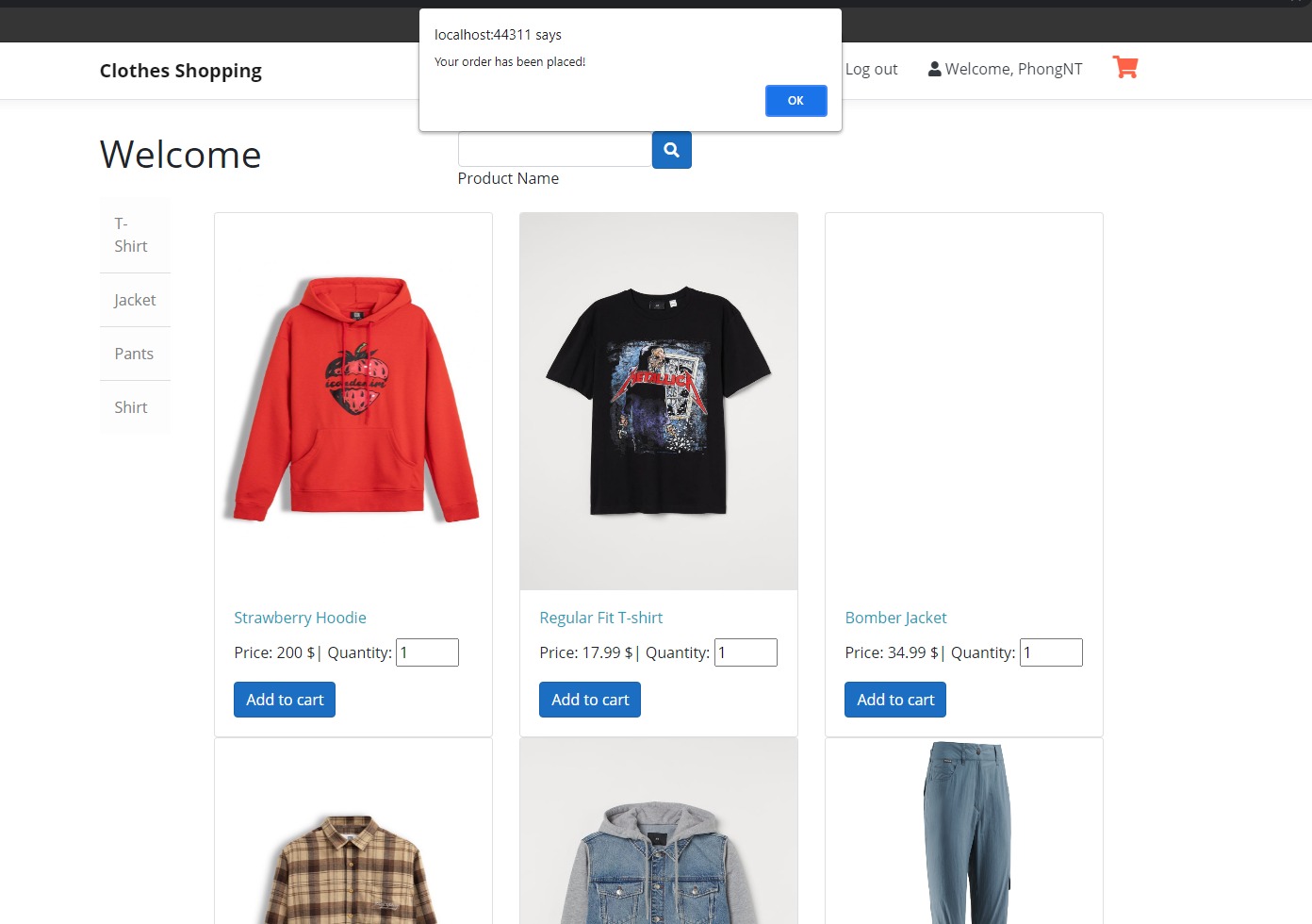

1. After clicking “Confirm” you will be redirected back to the homepage and a popup will show up for order placement status confirmation.

# Admin

These are functions for an admin.

**Test account:**

**Email:** phongntse150974@fpt.edu.vn

**Password:** 123456789

## Create product

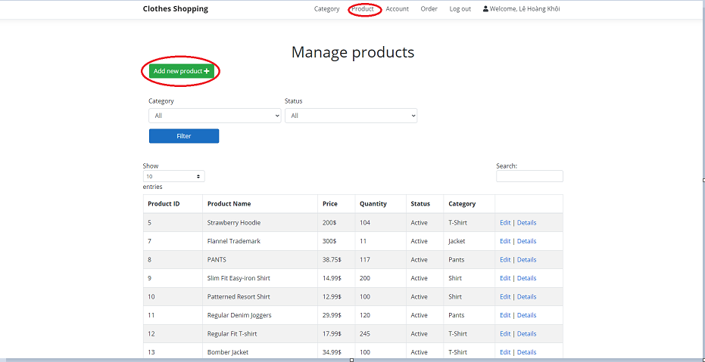

1. Choose the **“Product”** section on the navbar.
2. Click **“Add new product button”** and the screen will display as below.

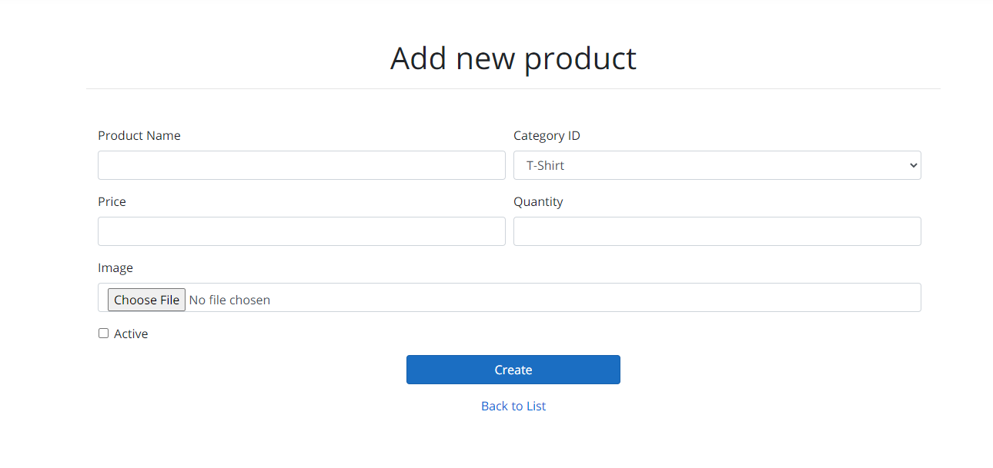

1. After filling all required information, click the **“Create”** button.
2. After creating a product without any error, the screen will display as below.

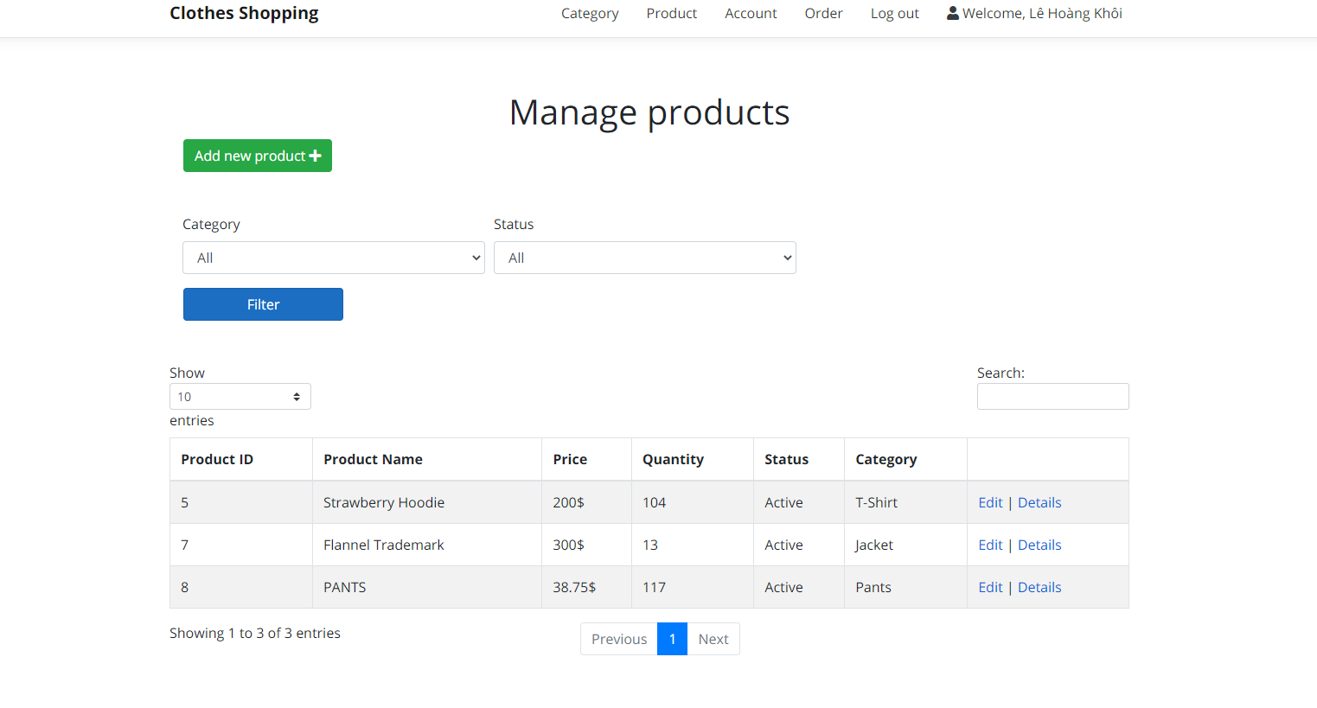

If there are any errors, there will be a message to inform, and the users must re-fill the form to continue to create.

## Edit product

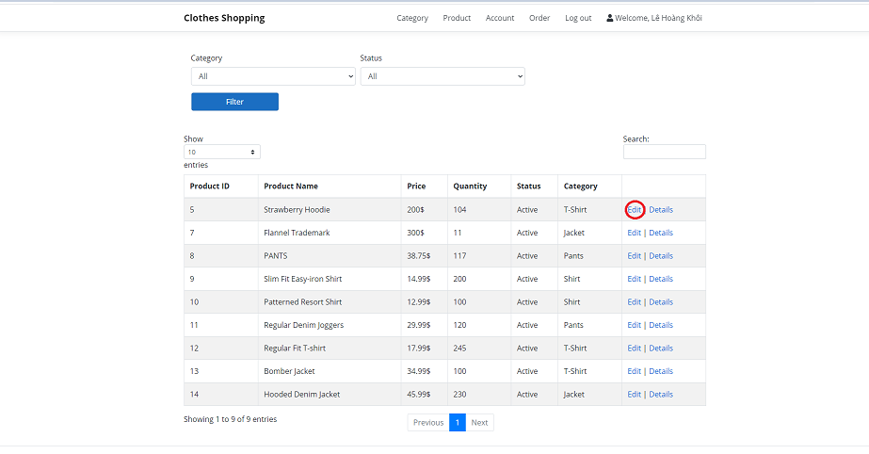

1. Choose the **“Product”** section on the navbar.
2. Click **“Edit”** in the table to update information of a specific product. The screen will display as below.

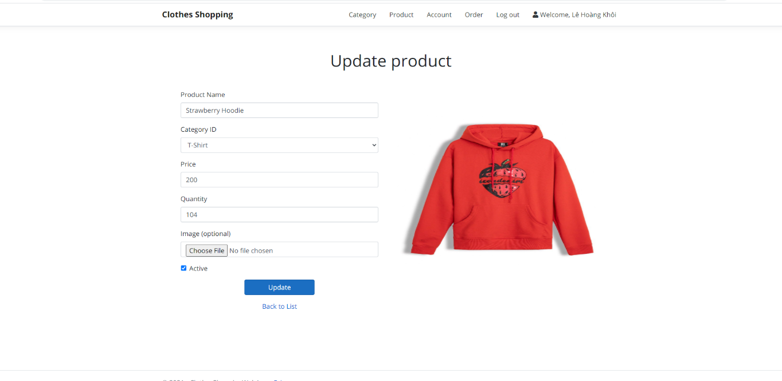

1. After editing information, click the **“Update”** button.
2. After updating a product without any error, the screen will display as below.



If there are any errors, there will be a message to inform, and the users must re-fill the form to continue to update.

## View product detail

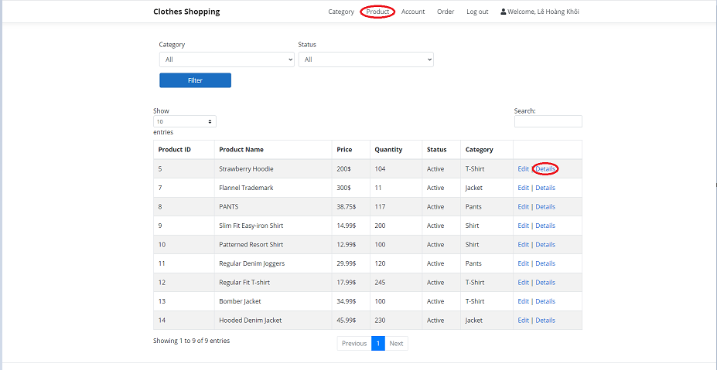

1. Choose the **“Product”** section on the navbar.
2. Click **“Details”** in the table to view information of a specific product. The screen will display as below.

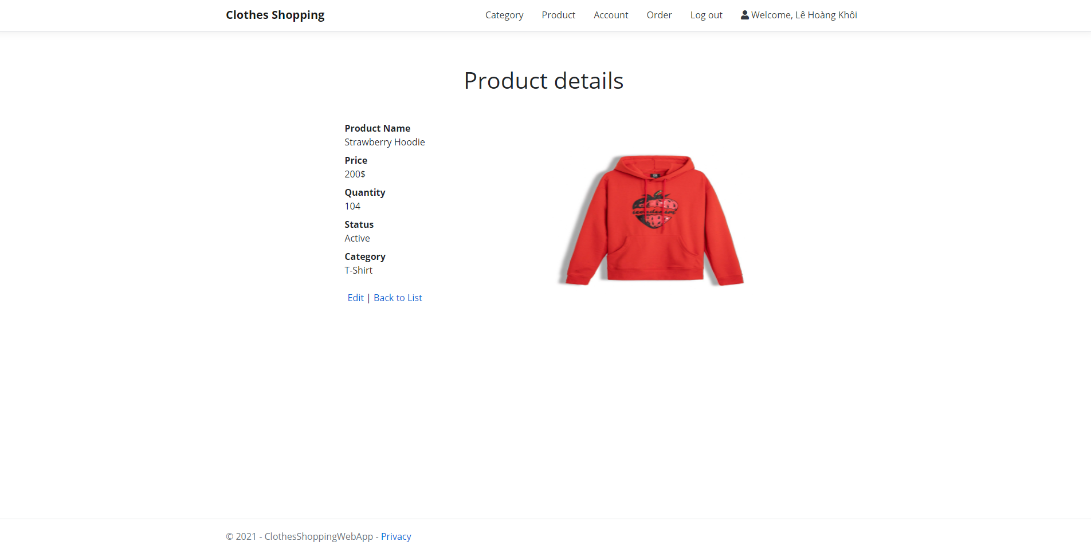

1. From this screen. admin can view all information about a specific product.

## Filter product

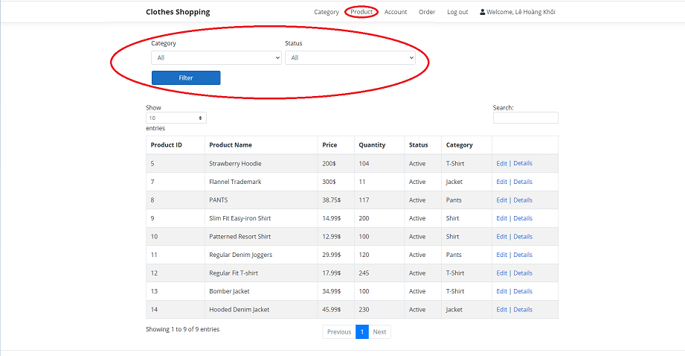

1. Choose the **“Product”** section on the navbar.
2. Choose category and status to filter. Then click the **“Filter”** button.
3. After completing process, the screen will display as below:

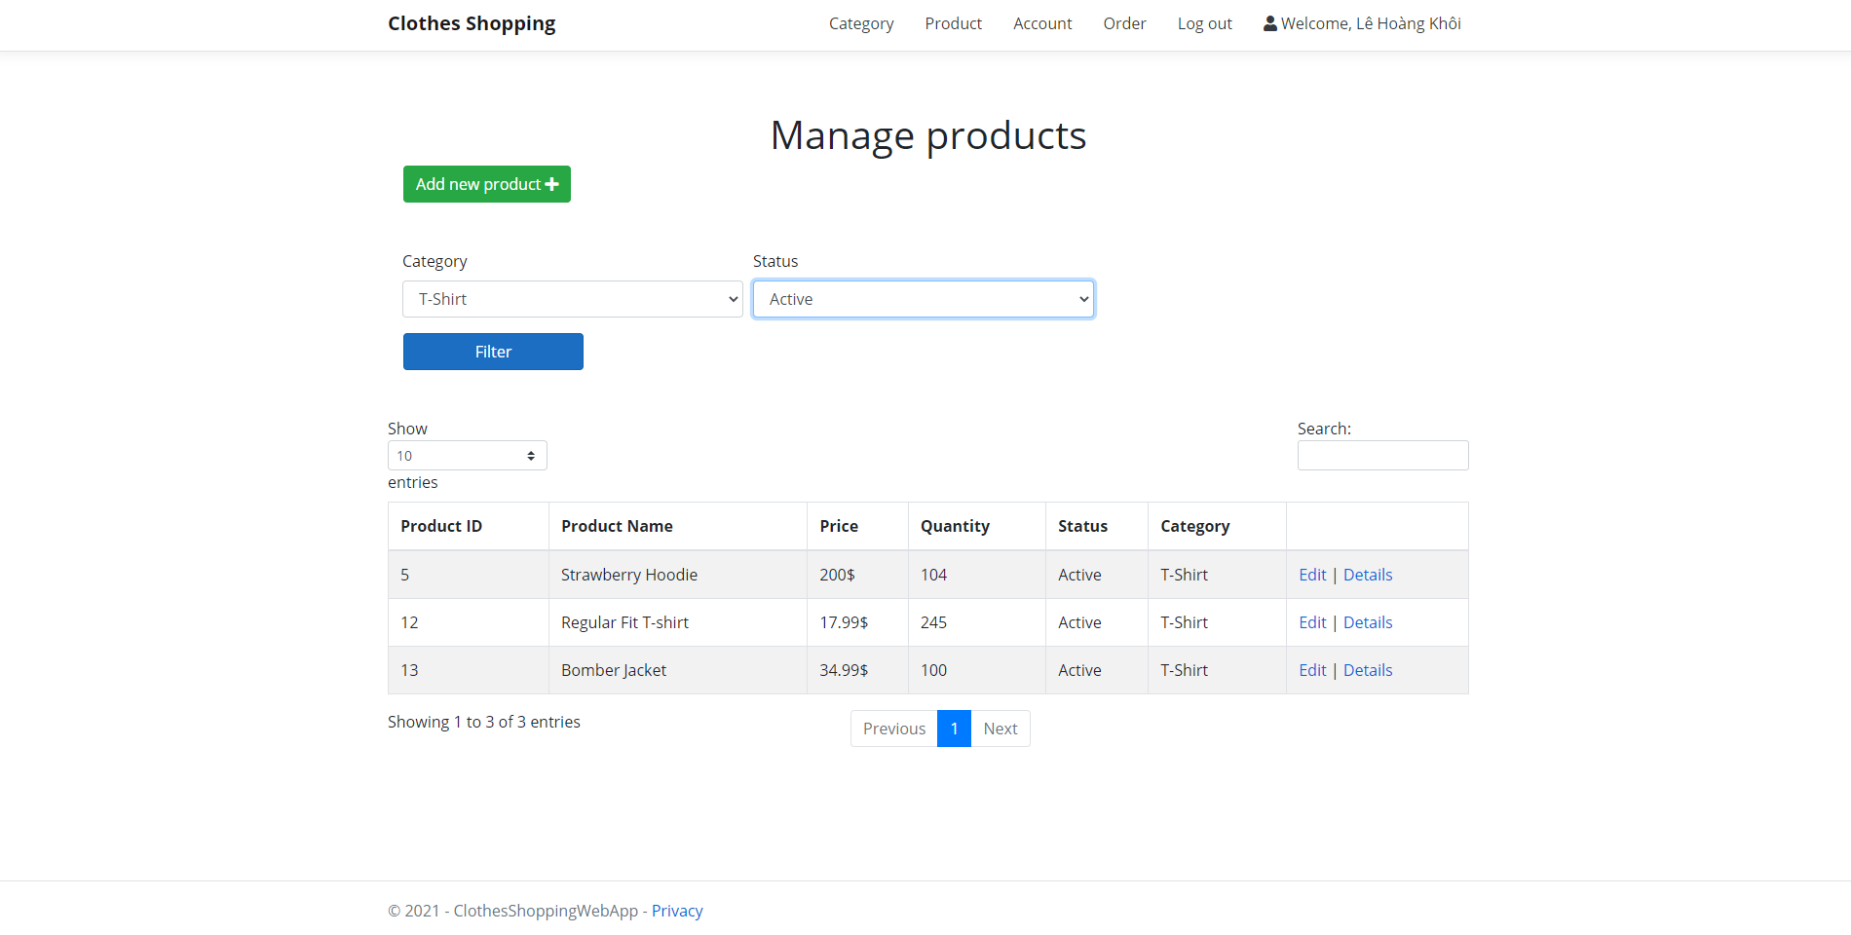

## Search product

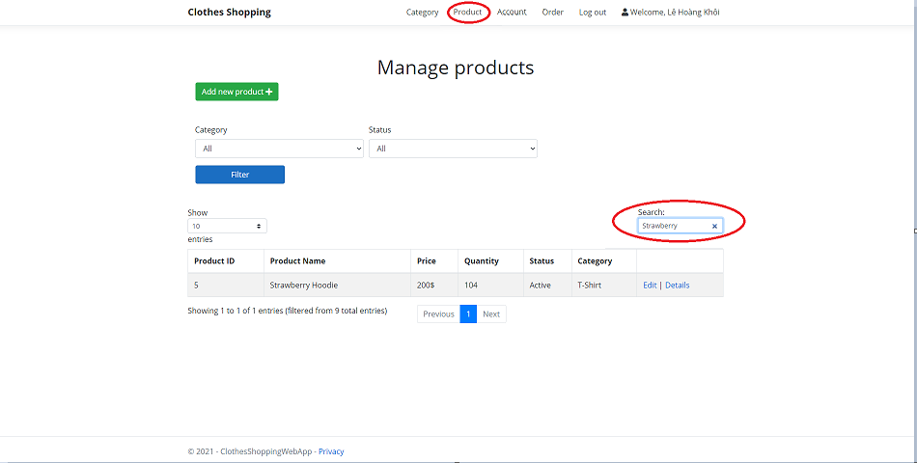

1. Choose the **“Product”** section on the navbar.
2. Admin type keyword to search in the search box.
3. The table will display the product list as you type.

## Create category

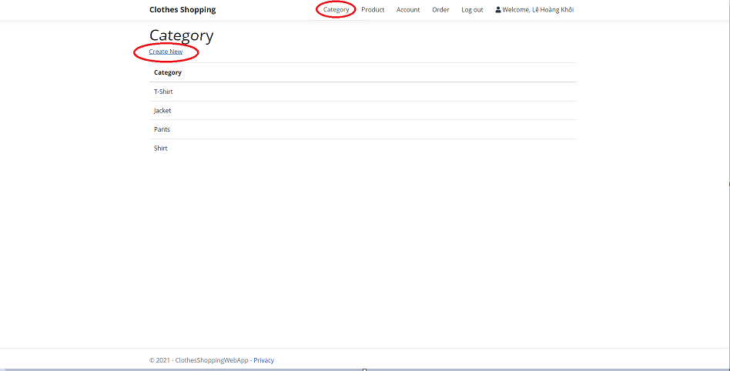

1. Choose the **“Category”** section on the navbar.
2. Click **“Create New”** below the title to create a new category. The screen will display as below.

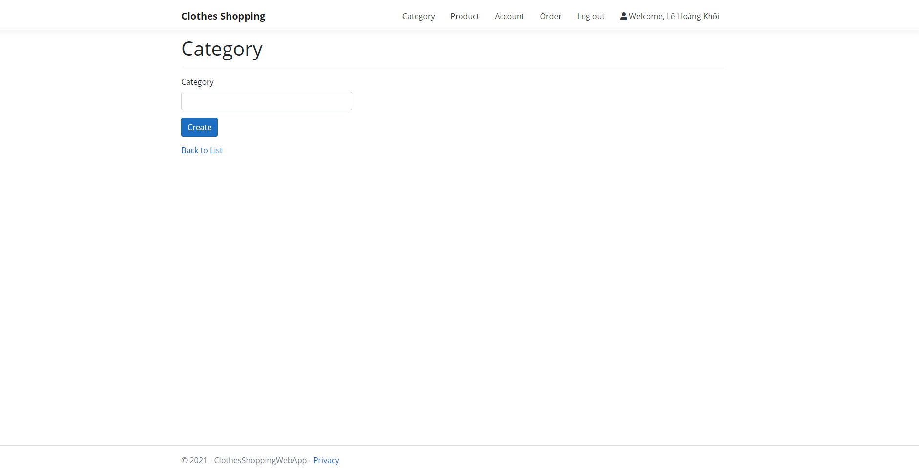

1. Enter the category name and click the **“Create”** button.
2. After completing process, the screen will return like below:

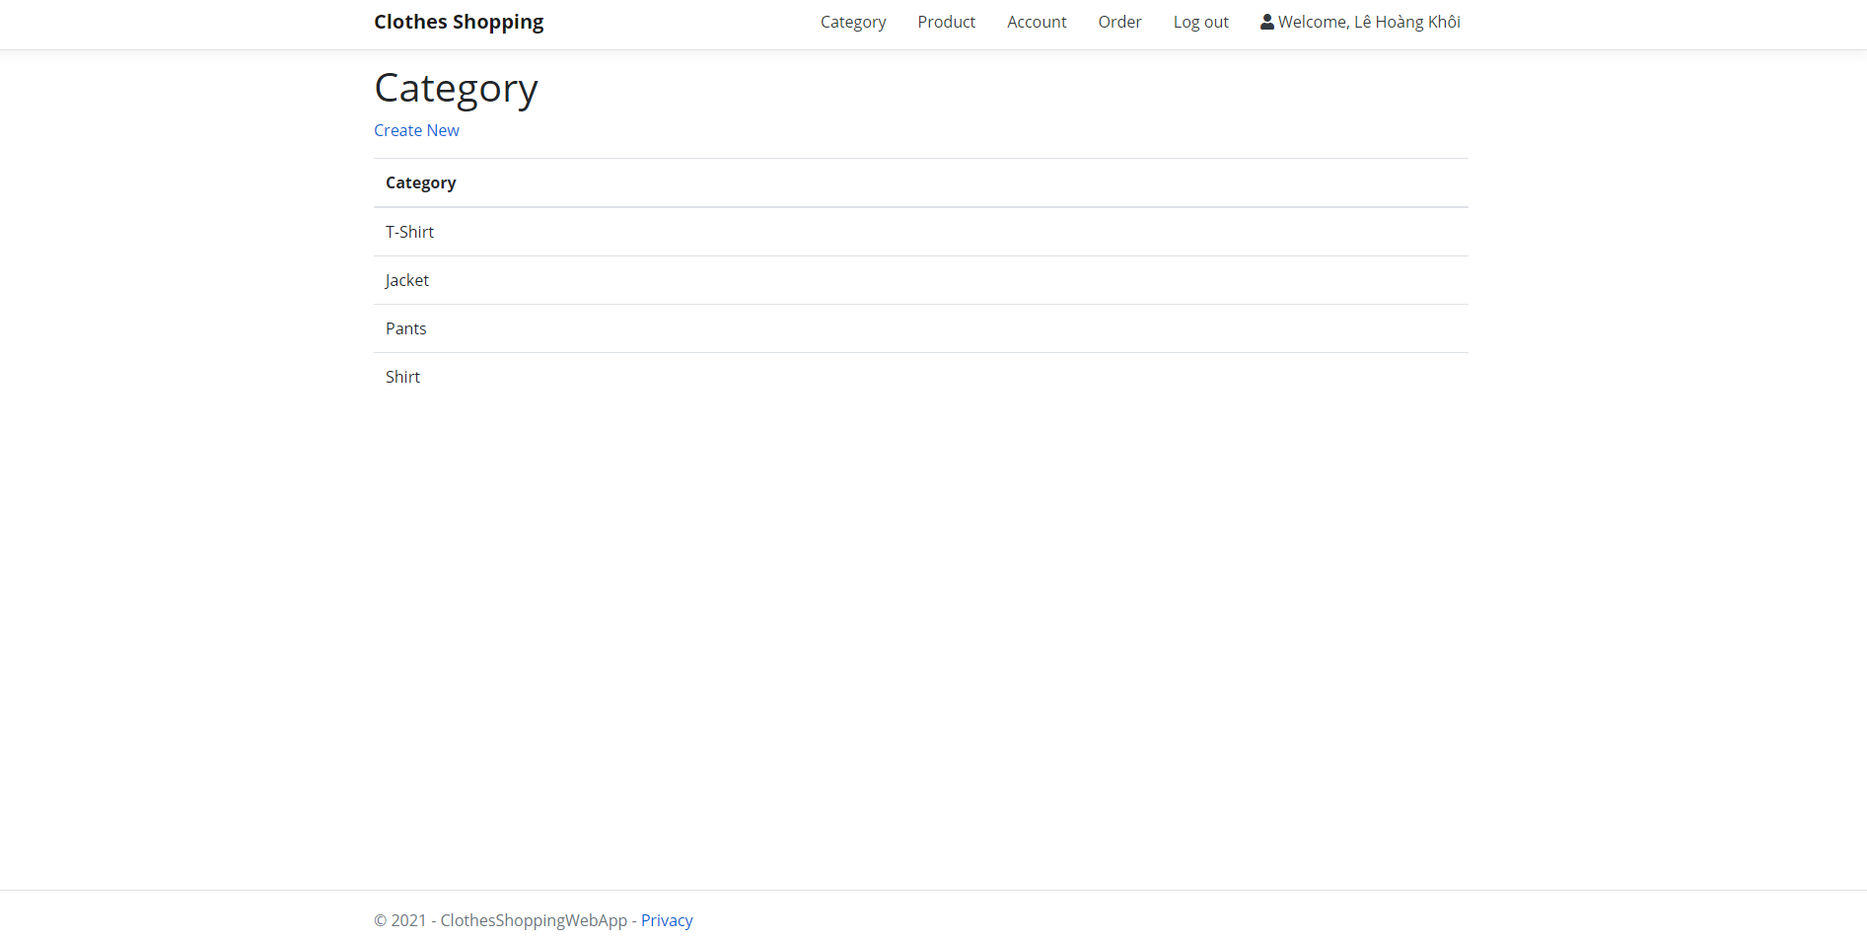

## View account list

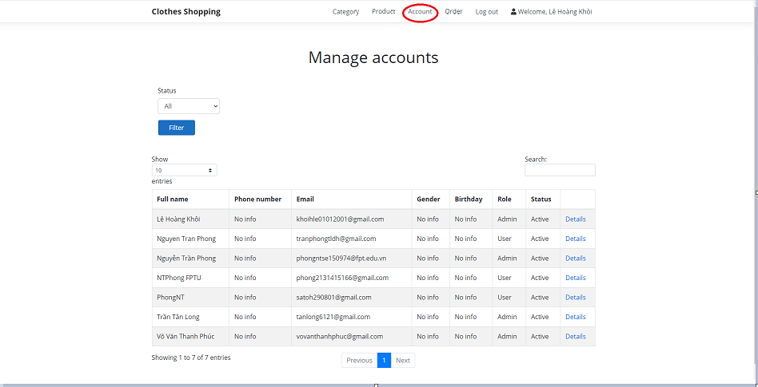

1. Choose the **“Account”** section on the navbar.
2. The account list will be displayed as above.

## Filter account by status



1. Choose the **“Account”** section on the navbar.
2. The account list will be displayed as above.
3. Choose status from the dropdown bar and then click the **“Filter”** button.

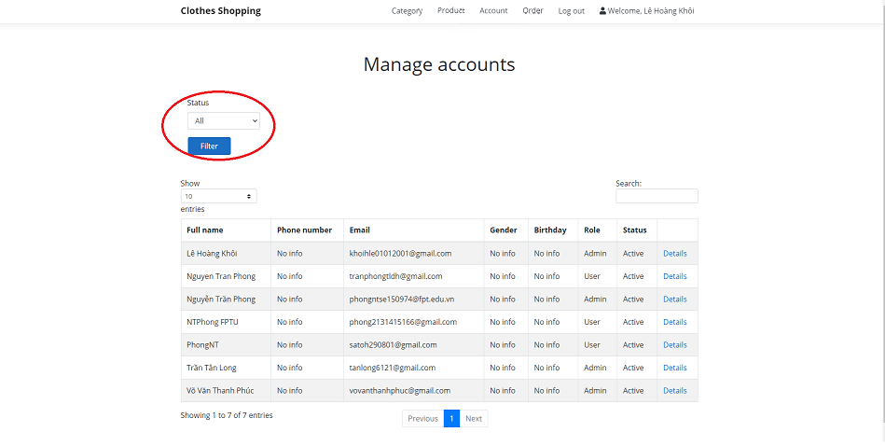

1. After completing filter process, the screen will return as below:

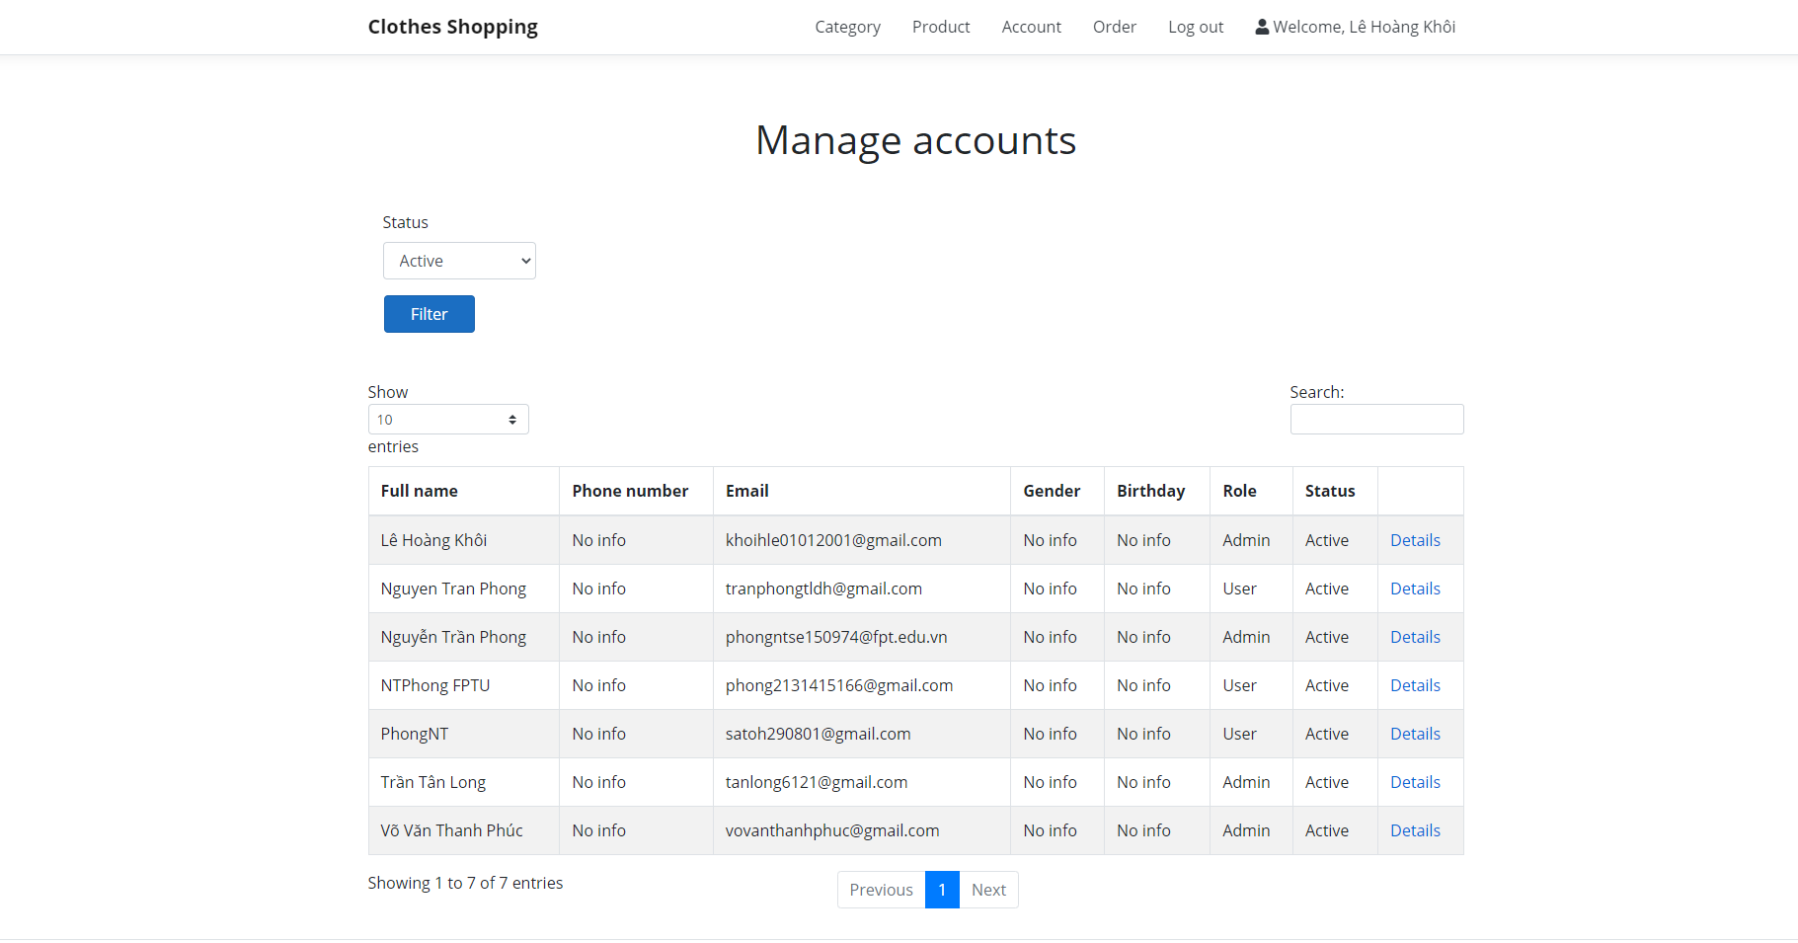

## View account detail

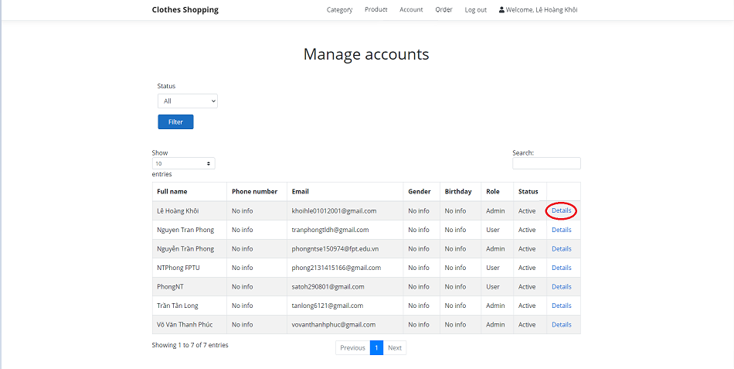

1. Choose the **“Account”** section on the navbar.
2. The account list will be displayed as above.
3. Users click the **“Details”** link for any specific account you want to review. The screen will display as below:

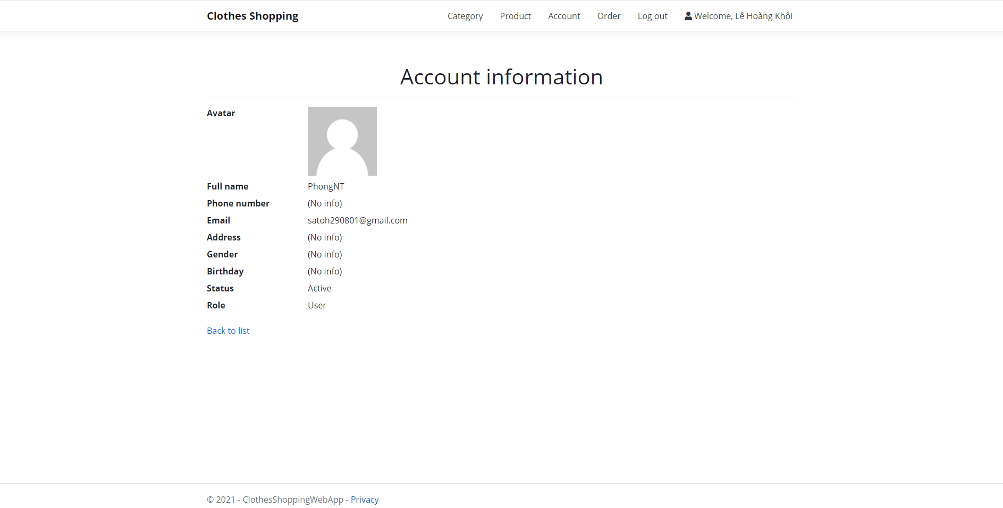

1. From this screen, you can view all information of a specific account.

## View order list

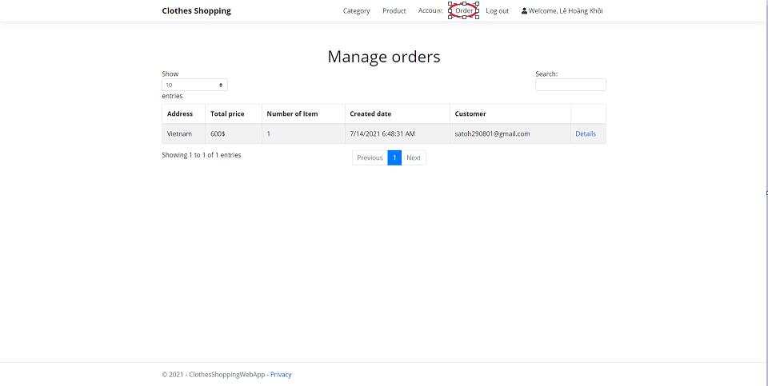

1. Choose the **“Order”** section on the navbar.
2. The order list will be displayed as above.

## View order detail



1. Choose the **“Order”** section on the navbar.
2. The order list will be displayed as above.
3. Choose a specific order and click **“Details”** link.

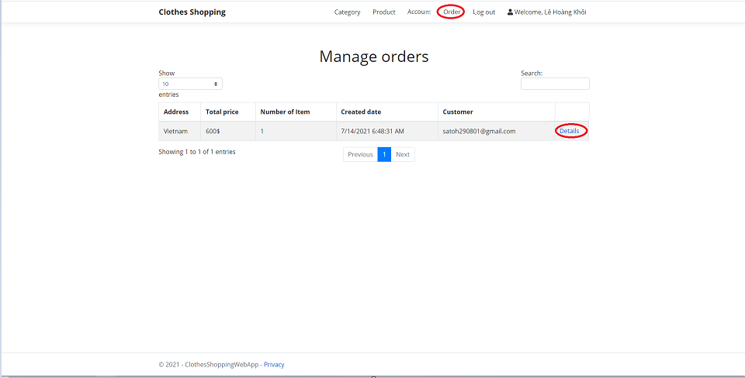

1. The screen will be displayed as below. From this screen, the admin can view all information about a specific order.

